**Protocol for Illumina 2bRAD sample preparation**

**Modified by Edwards Lab**

[Galina Aglyamova (aglyamova@austin.utexas.edu](mailto:aglyamova@austin.utexas.edu)) [Mikhail Matz (matz@utexas.edu](mailto:matz@utexas.edu))

Last updated: July 9 2014

Modified by Edwards Lab August 11 2016

*November 17 2015- old version, corrected errors within pooling ligations into 12-plex group step.

**Overview**

This is a modification of the protocol described in Wang et al, Nature Methods

2012 2b-RAD paper (doi:10.1038/nmeth.2023) re-designed for Illumina HiSeq and BcgI enzyme (https://www.neb.com/products/R0545-BcgI).

1. Restriction digest. Genomic DNA is digested with a type IIB restriction enzyme to produce restriction fragments of uniform length.

2. Ligation. Adaptors, barcoded for 3’ end and generic for 5’, are ligated to the cohesive ends generated by restriction digest. Overnight ligation at +4°C, then heat-inactivate the ligase for 10 min at 65oC.

3. Pool ligations with different 3’ barcodes into groups of 12 (because we have

12 different 3’ ligation adapters). Determine proportions from gel picture

(regular pcr) or by qPCR.

4. Amplification and barcoding of pooled ligations.

5. Purification of the target 170 bp band by gel-electrophoresis (the only purification step in the whole procedure).

6. Quantification and mixing in equal proportions.

**Digest**

1. Prepare a 4 µl high-quality genomic DNA sample containing 200-500 ng DNA. Samples concentrated using a speedvac with temperature turned off. Ideally, samples should have the same amount of DNA.

2. Prepare a digestion master mix. The following recipe is for a single reaction, so multiply by the number of samples plus some small amount for pipetting error.

NEB Buffer #3 0.6 µl

150 µM SAM 0.4 µl

BcgI (1 U µl-1) 0.5 µl

H2O 0.5 µl

3. Combine 2 µl master mix with each 4 µl DNA sample (6 µl total volume).

Cover this preparation with a drop of mineral oil. Incubate at 37°C 1 hr. Inactivate the enzyme at 65°C for 20 min. Hold samples on ice.

4. To increase digestion efficiency add 0.5 µl of enzyme after the initial 1h incubation and incubate for one more hour before heat-inactivation.

**\*The key criterion for whether the library is good is the number of PCR cycles required to amplify the target band, later in the protocol – it should be 15 or less for full-representation 2bRAD**

**Ligation**

In this step adaptors are ligated to the restriction fragments produced above.

1. Prepare double stranded adaptors by combining each pair of primers

(illBC-ii, antiBC-ii). The oligonucleotide combination used for each alternative

2b-RAD preparations and sequences of each oligo are provided at the end of this document.

For generic **Adaptor 1**, mix 5Ill-NN (10 µM) with the same volume of anti-Ill

(10 µM).

For barcoded **Adaptor 2**, mix each par: 3IllBC(1-12) (10 µM) with the same volume of antiBC(1-12) (10 µM).

Incubate at 42°C in thermocycler for 10 minutes then keep at room temperature until

ligation.

2. Prepare 12 master mixes for ligations (one for each barcoded 3’ primer).

This recipe is for a single reaction, so scale up as needed.

10 mM ATP 0.5 µl

10X T4 ligase buffer 2.0 µl

5 µM Adaptor 1 1.0 µl

5 µM Adaptor 2(1-12) 1.0 µl

T4 DNA ligase (NEB M0202L) 1.0 µl

NFW (nuclease-free water) 14.5 µl

3. Combine 20 µl master mix with the remaining 5 µl of digested DNA (25 µl total volume). Incubate at 16°C for 16 hours then reduce to 4°C. To end ligation heat at 65oC for 10 min to inactivate the ligase.

**Pooling ligations into 12-plex groups**

Samples barcoded at the 3’ end by different ligation Adapters 2 (1-12) can be pooled into groups of 12. Each such group (you will end up with 8 such groups in a 96 well plate) works as a single sample sample in the subsequent Amplification and Purification.

1. Use standard PCR with 15 cycles estimate the brightness of the bands on a gel. Mix 5µl (most efficient), 10, 15 or 20µl (least efficient) of each ligation in groups of twelve. (See figure 1)

For each reaction prepare the following master mix:

NFW 1.9 µl

10 µM IC1-P5 0.4 µl

10 µM IC2-P7 0.4 µl

10 µM Mpx primer 0.3 µl

Phusion mastermix w/ HF buffer 10.0 µl #NEB M0531S

2. Combine 13 µl master mix with 4 µl ligation, add 3 µl of 1 µM Ill-Rad-bc

(barcode-bearing) primer to each reaction, and amplify as follows:

x14

1. While PCR is running prepare a large (must fit 96 samples+ a few ladders) 2% agarose gel.
2. Add 5uL of Orange (Green colored) loading to each well of your PCR plate, mix.
3. Add 12.5uL from PCR plate to each well of the large gel.
4. For the ladder add 6uL of Low Molecular Weight ladder.
5. Add 15uL to the RED (+) of ethidium bromide to the buffer of the gel rig and mix before starting.
6. Run at 105 volts for ~65-70mins (Check a few times while running)
7. Image on gel imager.
8. Estimate the brightness of the bands on a gel. Mix 5µl (most efficient), 10, 15 or 20µl (least efficient) of each ligation pool across 8 row (12 samples /columns per pool). (See figure 1)

C:\Users\Joel\Downloads\2B RAD 1st run 96 samples (working!).tifFigure 1.

96 samples run on a test PCR of 14 cycles (cycle at which all samples produced a clear band). All samples mark 5 or unmarked are of high efficacy (5uL added to pool). Samples marked 10 are of lower efficacy (10uL added to pool).

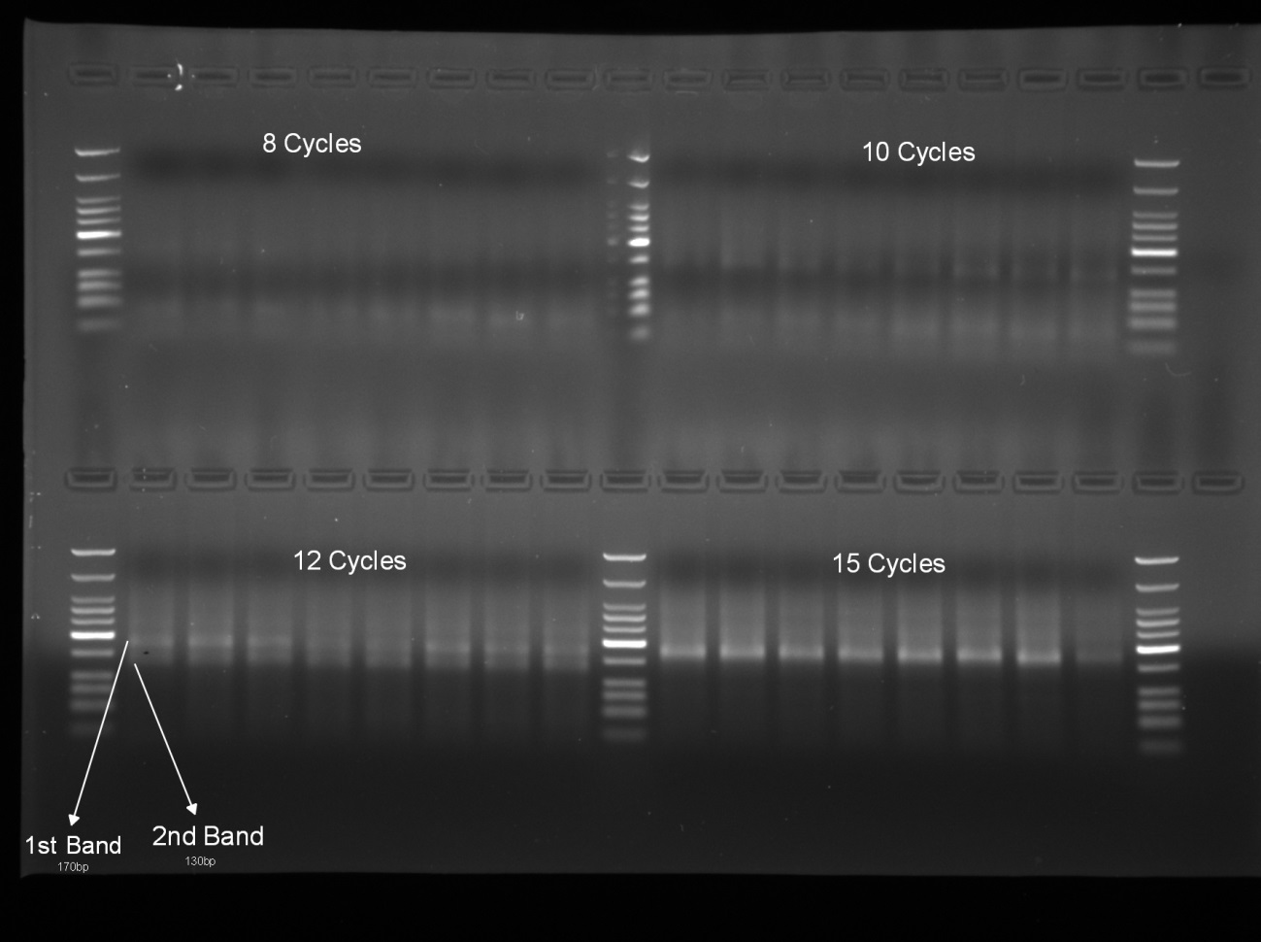Figure 2.

Amplification cycle test (5uL sample 2uL orange loading dye) on 2% Agarose gel using 1x TBE.

**Amplification**

Prepare a test-scale PCR to determine optimum cycle number and evaluate relative yield across samples.

1. For each reaction prepare the following master mix:

NFW 1.9 µl

10 µM IC1-P5 0.4 µl

10 µM IC2-P7 0.4 µl

10 µM Mpx primer 0.3 µl

Phusion mastermix w/ HF buffer 10.0 µl #NEB M0531S

2. Combine 13 µl master mix with 4 µl ligation, add 3 µl of 1 µM Ill-Rad-bc

(barcode-bearing) primer to each reaction, and amplify as follows:

x14

3. Sample 5 µl from each reaction at few time points. For example, at 8, 10 and 12 cycles. Load these products on a 2% agarose gel with a low molecular weight marker to confirm molecular weight of PCR product. (see Figure 2)

4. Select the minimum number of cycles that produces a visible, but not over-amplified, product at ~170 bp. You might also see a 130bp band, which this seems to be an artifact from the carried-over ligase (make sure to heat-inactivate the ligase before mixing the PCR reaction

**Large Scale PCR**

1. Prepare the following master mix for each sample:

NFW 4.75 µl

10 µM Mpx primer 0.75 µl

10 µM IC1-P5 1 µl

10 µM IC2-P7 1 µl

Phusion mastermix w/ HF buffer 25.0 µl #NEB M0531S

1. Combine 30 µl master mix with 10 µl ligation (group 1-8), add 7.5 µl of 1

µM Ill-Rad-bc (barcode-bearing) primer individually to each reaction, and amplify using the temperature profile as in 2 above with the cycle number as determined in 4

**Purification**

In this step the target band is gel-extracted to exclude high-molecular weight fragments and any chaff that may emerge during PCR (e.g., primer dimers).

1. Prepare a 2% agarose gel using TBE or TB. Use a normal comb and tape together two wells such that 50 µl sample loading plus 10 µl loading dye can be accommodated.

2. Load the entire volume of each reaction alongside a low-molecular weight ladder. Run gel at low voltage for a long time until bands at

150bp and 200bp will clearly resolved. In our experience 100V for 70 minutes produce the good separation.

3. View the gel briefly (<30 seconds) on a UV or appropriate for your DNA dye black-light transilluminator set at low intensity to verify the presence of target bands and adequate separation of molecular weight standards to resolve bands at ~170 bp and ~130 bp. Typically ~5 cm run distance is sufficient.

1. 4. Cut out target band of 170 bp in a narrow gel slice, avoiding the edges of the lane (i.e., cut out the middle 70-75% of the band). Cut just inside the bottom boundary of the target band to avoid getting anything smaller than 170bp. Run the slice through a MinElute Gel Extraction Kit (cat# 28604, Qiagen)

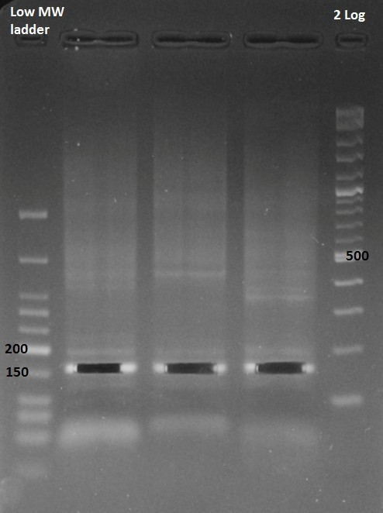

Figure 3. Gel Extraction

**Pooling for Sequencing**

In this step samples pools are quantified, converted to nM, and pooled into a single library for sequencing on an Illumina platform.

1. Quantify the 8 sample pools using a Qubit fluorometer, record the concentration in ng/uL.
2. Calculate the nM of the sample using the following equation.
3. Pool the sample pools in equal nM concentration into a single library consisting of 30uL at 10nM.

**Oligonucleotide sequences for Illumina HiSeq**

**Name Sequence (5’ – 3’)**

anti-ILL AGATCGGAAGAGC/3InvdT1/

5ILL-NN CTACACGACGCTCTTCCGATCTNN

3ILL-NN CAGACGTGTGCTCTTCCGATCTNN

5ILL-NG2 CTACACGACGCTCTTCCGATCTNG

3ILL-NG2 CAGACGTGTGCTCTTCCGATCTNG

ILL-Mpx3 AATGATACGGCGACCACCGAGATCTACACTCTTTCCCTACACGACGCTCTTCCGAT

ILL-RAD-bc4 CAAGCAGAAGACGGCATACGAGAT [barcode]5 GTGACTGGAGTTCAGACGTGTGCTCTTCCGAT

IC1-P5 AATGATACGGCGACCACCGA

IC2-P7 CAAGCAGAAGACGGCATACGA

1 InvdT: inverted dT to prevent extension by DNA polymerase.

2 These two adaptors can be used to reduce representation of the 2b-RAD tags down to approximately 1/16th of the total number. This is a useful cost-lowering trick for applications such as basic population genetics, relatedness analysis, or QTL mapping, the power of which would max out already at a few hundred polymorphic markers.

3 This is a standard Illumina-“universal” primer in TrueSeq v.3 (configuration 5’ P5-index2- R1primingSite 3’)

4 “bc” stands for “barcode”, and is typically replaced by the barcode number (or other barcode- specific identifier) in the actual name of the primer. This primer can be substituted for a standard TruSeq v.3 barcoded oligo of the configuration 5’ P7-Index1-R2primingSite 3’.

5 barcode: a 6-base sequence easily distinguishable from other sequences on that same

sequencing run. A list of good working barcodes can be found here:

https://wikis.utexas.edu/display/GSAF/Illumina+-+all+flavors

BUT NOTE that the barcode sequences listed at that site are in fact REVERSE COMPLEMENTS relative to what needs to be written in the ILL-RAD-bc oligo (we had so many fun moments because of that)

**Secondary-barcoded adapters for Ligation**

3illBC1   CAGACGTGTGCTCTTCCGATCT  ACCA  NN

3illBC2   CAGACGTGTGCTCTTCCGATCT  GTCT  NN

3illBC3   CAGACGTGTGCTCTTCCGATCT  TGGT  NN

3illBC4   CAGACGTGTGCTCTTCCGATCT  CACT  NN

3illBC5   CAGACGTGTGCTCTTCCGATCT  GATG  NN

3illBC6   CAGACGTGTGCTCTTCCGATCT  TCAC  NN

3illBC7   CAGACGTGTGCTCTTCCGATCT  CTGA  NN

3illBC8   CAGACGTGTGCTCTTCCGATCT  AAGC  NN

3illBC9   CAGACGTGTGCTCTTCCGATCT  GTAG  NN

3illBC10   CAGACGTGTGCTCTTCCGATCT  GACA  NN

3illBC11   CAGACGTGTGCTCTTCCGATCT  GTGA  NN

3illBC12   CAGACGTGTGCTCTTCCGATCT  AGTC  NN

antiBC1   TGGT  AGATCGGA/3InvdT/

antiBC2   AGAC  AGATCGGA/3InvdT/

antiBC3   ACCA  AGATCGGA/3InvdT/

antiBC4   AGTG  AGATCGGA/3InvdT/  antiBC5   CATC  AGATCGGA/3InvdT/  aantiBC6   GTGA  AGATCGGA/3InvdT/  antiBC7   TCAG  AGATCGGA/3InvdT/  antiBC8   GCTT  AGATCGGA/3InvdT/  antiBC9   CTAC  AGATCGGA/3InvdT/  aantiBC10   TGTC  AGATCGGA/3InvdT/  antiBC11   TCAC  AGATCGGA/3InvdT/  antiBC12   GACT  AGATCGGA/3InvdT/

Barcoded PCR primers (can be substituted for standard TruSeq v.3 oligos: 5’ P7-**Index1**- R2primer 3’ )

ILL-RAD01 CAA GCA GAA GAC GGC ATA CGA GAT **CGT GAT** GTG ACT GGA GTT CAG ACG TGT GCT CTT CCG AT ILL-RAD02 CAA GCA GAA GAC GGC ATA CGA GAT ACA TCG GTG ACT GGA GTT CAG ACG TGT GCT CTT CCG AT ILL-RAD03 CAA GCA GAA GAC GGC ATA CGA GAT GCC TAA GTG ACT GGA GTT CAG ACG TGT GCT CTT CCG AT ILL-RAD04 CAA GCA GAA GAC GGC ATA CGA GAT TGG TCA GTG ACT GGA GTT CAG ACG TGT GCT CTT CCG AT ILL-RAD05 CAA GCA GAA GAC GGC ATA CGA GAT CAC TGT GTG ACT GGA GTT CAG ACG TGT GCT CTT CCG AT ILL-RAD06 CAA GCA GAA GAC GGC ATA CGA GAT ATT GGC GTG ACT GGA GTT CAG ACG TGT GCT CTT CCG AT ILL-RAD07 CAA GCA GAA GAC GGC ATA CGA GAT GAT CTG GTG ACT GGA GTT CAG ACG TGT GCT CTT CCG AT ILL-RAD08 CAA GCA GAA GAC GGC ATA CGA GAT TCA AGT GTG ACT GGA GTT CAG ACG TGT GCT CTT CCG AT ILL-RAD09 CAA GCA GAA GAC GGC ATA CGA GAT CTG ATC GTG ACT GGA GTT CAG ACG TGT GCT CTT CCG AT ILL-RAD10 CAA GCA GAA GAC GGC ATA CGA GAT AAG CTA GTG ACT GGA GTT CAG ACG TGT GCT CTT CCG AT ILL-RAD11 CAA GCA GAA GAC GGC ATA CGA GAT GTA GCC GTG ACT GGA GTT CAG ACG TGT GCT CTT CCG AT ILL-RAD12 CAA GCA GAA GAC GGC ATA CGA GAT TAC AAG GTG ACT GGA GTT CAG ACG TGT GCT CTT CCG AT ILL-RAD13 CAA GCA GAA GAC GGC ATA CGA GAT TTG ACT GTG ACT GGA GTT CAG ACG TGT GCT CTT CCG AT ILL-RAD14 CAA GCA GAA GAC GGC ATA CGA GAT GGA ACT GTG ACT GGA GTT CAG ACG TGT GCT CTT CCG AT ILL-RAD15 CAA GCA GAA GAC GGC ATA CGA GAT TGA CAT GTG ACT GGA GTT CAG ACG TGT GCT CTT CCG AT ILL-RAD16 CAA GCA GAA GAC GGC ATA CGA GAT GGA CGG GTG ACT GGA GTT CAG ACG TGT GCT CTT CCG AT ILL-RAD17 CAA GCA GAA GAC GGC ATA CGA GAT CTC TAC GTG ACT GGA GTT CAG ACG TGT GCT CTT CCG AT ILL-RAD18 CAA GCA GAA GAC GGC ATA CGA GAT GCG GAC GTG ACT GGA GTT CAG ACG TGT GCT CTT CCG AT ILL-RAD19 CAA GCA GAA GAC GGC ATA CGA GAT TTT CAC GTG ACT GGA GTT CAG ACG TGT GCT CTT CCG AT ILL-RAD20 CAA GCA GAA GAC GGC ATA CGA GAT GGC CAC GTG ACT GGA GTT CAG ACG TGT GCT CTT CCG AT ILL-RAD21 CAA GCA GAA GAC GGC ATA CGA GAT CGA AAC GTG ACT GGA GTT CAG ACG TGT GCT CTT CCG AT ILL-RAD22 CAA GCA GAA GAC GGC ATA CGA GAT CGT ACG GTG ACT GGA GTT CAG ACG TGT GCT CTT CCG AT ILL-RAD23 CAA GCA GAA GAC GGC ATA CGA GAT CCA CTC GTG ACT GGA GTT CAG ACG TGT GCT CTT CCG AT ILL-RAD24 CAA GCA GAA GAC GGC ATA CGA GAT GCT ACC GTG ACT GGA GTT CAG ACG TGT GCT CTT CCG AT ILL-RAD25 CAA GCA GAA GAC GGC ATA CGA GAT ATC AGT GTG ACT GGA GTT CAG ACG TGT GCT CTT CCG AT ILL-RAD26 CAA GCA GAA GAC GGC ATA CGA GAT GCT CAT GTG ACT GGA GTT CAG ACG TGT GCT CTT CCG AT ILL-RAD27 CAA GCA GAA GAC GGC ATA CGA GAT AGG AAT GTG ACT GGA GTT CAG ACG TGT GCT CTT CCG AT ILL-RAD28 CAA GCA GAA GAC GGC ATA CGA GAT CTT TTG GTG ACT GGA GTT CAG ACG TGT GCT CTT CCG AT ILL-RAD29 CAA GCA GAA GAC GGC ATA CGA GAT TAG TTG GTG ACT GGA GTT CAG ACG TGT GCT CTT CCG AT ILL-RAD30 CAA GCA GAA GAC GGC ATA CGA GAT CCG GTG GTG ACT GGA GTT CAG ACG TGT GCT CTT CCG AT ILL-RAD31 CAA GCA GAA GAC GGC ATA CGA GAT ATC GTG GTG ACT GGA GTT CAG ACG TGT GCT CTT CCG AT ILL-RAD32 CAA GCA GAA GAC GGC ATA CGA GAT TGA GTG GTG ACT GGA GTT CAG ACG TGT GCT CTT CCG AT ILL-RAD33 CAA GCA GAA GAC GGC ATA CGA GAT CGC CTG GTG ACT GGA GTT CAG ACG TGT GCT CTT CCG AT ILL-RAD34 CAA GCA GAA GAC GGC ATA CGA GAT GCC ATG GTG ACT GGA GTT CAG ACG TGT GCT CTT CCG AT ILL-RAD35 CAA GCA GAA GAC GGC ATA CGA GAT AAA ATG GTG ACT GGA GTT CAG ACG TGT GCT CTT CCG AT ILL-RAD36 CAA GCA GAA GAC GGC ATA CGA GAT TGT TGG GTG ACT GGA GTT CAG ACG TGT GCT CTT CCG AT ILL-RAD37 CAA GCA GAA GAC GGC ATA CGA GAT ATT CCG GTG ACT GGA GTT CAG ACG TGT GCT CTT CCG AT ILL-RAD38 CAA GCA GAA GAC GGC ATA CGA GAT AGC TAG GTG ACT GGA GTT CAG ACG TGT GCT CTT CCG AT ILL-RAD39 CAA GCA GAA GAC GGC ATA CGA GAT GTA TAG GTG ACT GGA GTT CAG ACG TGT GCT CTT CCG AT

ILL-RAD40 CAA GCA GAA GAC GGC ATA CGA GAT TCT GAG GTG ACT GGA GTT CAG ACG TGT GCT CTT CCG AT ILL-RAD41 CAA GCA GAA GAC GGC ATA CGA GAT GTC GTC GTG ACT GGA GTT CAG ACG TGT GCT CTT CCG AT ILL-RAD42 CAA GCA GAA GAC GGC ATA CGA GAT TAG CGC GTG ACT GGA GTT CAG ACG TGT GCT CTT CCG AT ILL-RAD43 CAA GCA GAA GAC GGC ATA CGA GAT CGA TTA GTG ACT GGA GTT CAG ACG TGT GCT CTT CCG AT ILL-RAD44 CAA GCA GAA GAC GGC ATA CGA GAT GCT GTA GTG ACT GGA GTT CAG ACG TGT GCT CTT CCG AT ILL-RAD45 CAA GCA GAA GAC GGC ATA CGA GAT ATT ATA GTG ACT GGA GTT CAG ACG TGT GCT CTT CCG AT ILL-RAD46 CAA GCA GAA GAC GGC ATA CGA GAT GAA TGA GTG ACT GGA GTT CAG ACG TGT GCT CTT CCG AT ILL-RAD47 CAA GCA GAA GAC GGC ATA CGA GAT TCG GGA GTG ACT GGA GTT CAG ACG TGT GCT CTT CCG AT ILL-RAD48 CAA GCA GAA GAC GGC ATA CGA GAT CTT CGA GTG ACT GGA GTT CAG ACG TGT GCT CTT CCG AT ILL-RAD49 CAA GCA GAA GAC GGC ATA CGA GAT TGC CGA GTG ACT GGA GTT CAG ACG TGT GCT CTT CCG AT ILL-RAD50 CAA GCA GAA GAC GGC ATA CGA GAT GTG TTT GTG ACT GGA GTT CAG ACG TGT GCT CTT CCG AT ILL-RAD51 CAA GCA GAA GAC GGC ATA CGA GAT CCT TCA GTG ACT GGA GTT CAG ACG TGT GCT CTT CCG AT ILL-RAD52 CAA GCA GAA GAC GGC ATA CGA GAT TAT GTT GTG ACT GGA GTT CAG ACG TGT GCT CTT CCG AT ILL-RAD53 CAA GCA GAA GAC GGC ATA CGA GAT GAC GCG GTG ACT GGA GTT CAG ACG TGT GCT CTT CCG AT ILL-RAD54 CAA GCA GAA GAC GGC ATA CGA GAT TGT ATC GTG ACT GGA GTT CAG ACG TGT GCT CTT CCG AT ILL-RAD55 CAA GCA GAA GAC GGC ATA CGA GAT CAC ACC GTG ACT GGA GTT CAG ACG TGT GCT CTT CCG AT ILL-RAD56 CAA GCA GAA GAC GGC ATA CGA GAT TTC TTA GTG ACT GGA GTT CAG ACG TGT GCT CTT CCG AT ILL-RAD57 CAA GCA GAA GAC GGC ATA CGA GAT CTC GCT GTG ACT GGA GTT CAG ACG TGT GCT CTT CCG AT ILL-RAD58 CAA GCA GAA GAC GGC ATA CGA GAT TAA CCG GTG ACT GGA GTT CAG ACG TGT GCT CTT CCG AT ILL-RAD59 CAA GCA GAA GAC GGC ATA CGA GAT AAA GCT GTG ACT GGA GTT CAG ACG TGT GCT CTT CCG AT ILL-RAD60 CAA GCA GAA GAC GGC ATA CGA GAT AGA CCA GTG ACT GGA GTT CAG ACG TGT GCT CTT CCG AT ILL-RAD61 CAA GCA GAA GAC GGC ATA CGA GAT GGG ATA GTG ACT GGA GTT CAG ACG TGT GCT CTT CCG AT ILL-RAD62 CAA GCA GAA GAC GGC ATA CGA GAT ACG ACA GTG ACT GGA GTT CAG ACG TGT GCT CTT CCG AT ILL-RAD63 CAA GCA GAA GAC GGC ATA CGA GAT GTG GGG GTG ACT GGA GTT CAG ACG TGT GCT CTT CCG AT ILL-RAD64 CAA GCA GAA GAC GGC ATA CGA GAT TCG TAT GTG ACT GGA GTT CAG ACG TGT GCT CTT CCG AT ILL-RAD65 CAA GCA GAA GAC GGC ATA CGA GAT CAA GGG GTG ACT GGA GTT CAG ACG TGT GCT CTT CCG AT ILL-RAD66 CAA GCA GAA GAC GGC ATA CGA GAT GCC GGT GTG ACT GGA GTT CAG ACG TGT GCT CTT CCG AT ILL-RAD67 CAA GCA GAA GAC GGC ATA CGA GAT CAG TAA GTG ACT GGA GTT CAG ACG TGT GCT CTT CCG AT ILL-RAD68 CAA GCA GAA GAC GGC ATA CGA GAT AGT TCC GTG ACT GGA GTT CAG ACG TGT GCT CTT CCG AT ILL-RAD69 CAA GCA GAA GAC GGC ATA CGA GAT AAT AAC GTG ACT GGA GTT CAG ACG TGT GCT CTT CCG AT ILL-RAD70 CAA GCA GAA GAC GGC ATA CGA GAT ACT TTT GTG ACT GGA GTT CAG ACG TGT GCT CTT CCG AT ILL-RAD71 CAA GCA GAA GAC GGC ATA CGA GAT TCC CTT GTG ACT GGA GTT CAG ACG TGT GCT CTT CCG AT ILL-RAD72 CAA GCA GAA GAC GGC ATA CGA GAT ATA CTT GTG ACT GGA GTT CAG ACG TGT GCT CTT CCG AT ILL-RAD73 CAA GCA GAA GAC GGC ATA CGA GAT AGA TGT GTG ACT GGA GTT CAG ACG TGT GCT CTT CCG AT ILL-RAD74 CAA GCA GAA GAC GGC ATA CGA GAT AAT CGT GTG ACT GGA GTT CAG ACG TGT GCT CTT CCG AT ILL-RAD75 CAA GCA GAA GAC GGC ATA CGA GAT CGG CGT GTG ACT GGA GTT CAG ACG TGT GCT CTT CCG AT ILL-RAD76 CAA GCA GAA GAC GGC ATA CGA GAT GAG AGT GTG ACT GGA GTT CAG ACG TGT GCT CTT CCG AT ILL-RAD77 CAA GCA GAA GAC GGC ATA CGA GAT GAT TCT GTG ACT GGA GTT CAG ACG TGT GCT CTT CCG AT ILL-RAD78 CAA GCA GAA GAC GGC ATA CGA GAT CCC AAT GTG ACT GGA GTT CAG ACG TGT GCT CTT CCG AT ILL-RAD79 CAA GCA GAA GAC GGC ATA CGA GAT ACG CGG GTG ACT GGA GTT CAG ACG TGT GCT CTT CCG AT ILL-RAD80 CAA GCA GAA GAC GGC ATA CGA GAT AGG GCG GTG ACT GGA GTT CAG ACG TGT GCT CTT CCG AT ILL-RAD81 CAA GCA GAA GAC GGC ATA CGA GAT CTG CAG GTG ACT GGA GTT CAG ACG TGT GCT CTT CCG AT ILL-RAD82 CAA GCA GAA GAC GGC ATA CGA GAT AAC TTC GTG ACT GGA GTT CAG ACG TGT GCT CTT CCG AT ILL-RAD83 CAA GCA GAA GAC GGC ATA CGA GAT GGG TGC GTG ACT GGA GTT CAG ACG TGT GCT CTT CCG AT ILL-RAD84 CAA GCA GAA GAC GGC ATA CGA GAT TCC TGC GTG ACT GGA GTT CAG ACG TGT GCT CTT CCG AT ILL-RAD85 CAA GCA GAA GAC GGC ATA CGA GAT CGC GGC GTG ACT GGA GTT CAG ACG TGT GCT CTT CCG AT ILL-RAD86 CAA GCA GAA GAC GGC ATA CGA GAT ACC GCC GTG ACT GGA GTT CAG ACG TGT GCT CTT CCG AT ILL-RAD87 CAA GCA GAA GAC GGC ATA CGA GAT TAA TAC GTG ACT GGA GTT CAG ACG TGT GCT CTT CCG AT ILL-RAD88 CAA GCA GAA GAC GGC ATA CGA GAT CAC GTA GTG ACT GGA GTT CAG ACG TGT GCT CTT CCG AT ILL-RAD89 CAA GCA GAA GAC GGC ATA CGA GAT ATG TGA GTG ACT GGA GTT CAG ACG TGT GCT CTT CCG AT ILL-RAD90 CAA GCA GAA GAC GGC ATA CGA GAT TAT AGA GTG ACT GGA GTT CAG ACG TGT GCT CTT CCG AT ILL-RAD91 CAA GCA GAA GAC GGC ATA CGA GAT TTT GCA GTG ACT GGA GTT CAG ACG TGT GCT CTT CCG AT ILL-RAD92 CAA GCA GAA GAC GGC ATA CGA GAT GTG CCA GTG ACT GGA GTT CAG ACG TGT GCT CTT CCG AT ILL-RAD93 CAA GCA GAA GAC GGC ATA CGA GAT CTA ACA GTG ACT GGA GTT CAG ACG TGT GCT CTT CCG AT ILL-RAD94 CAA GCA GAA GAC GGC ATA CGA GAT ATA GAA GTG ACT GGA GTT CAG ACG TGT GCT CTT CCG AT